**Recommendations for Big Mountain Resort**

The current price of Big Mountain Resort is $81.00 and its place among the other resorts in Montana state and the whole country has been shown in the following figures.

|  |  |
| --- | --- |
| /var/folders/lw/9m9xkqhj0t75vslnql4xz0sw0000gn/T/com.microsoft.Word/Content.MSO/403A1272.tmp | /var/folders/lw/9m9xkqhj0t75vslnql4xz0sw0000gn/T/com.microsoft.Word/Content.MSO/8C008B50.tmp |

We used forest regressor model to predict the price for ticket. The model predicts $95.87 for price of ticket. Even with the expected mean absolute error of $10.39, this suggests there is room for an increase. So the current price of ticket is undervalued considering the facilities of resort. The validity of our model lies in the assumption that other resorts accurately set their prices according to what the market (the ticket-buying public) supports.

Features that came up as important in the modeling are as follow and the amplitude of bars shows the order of importance.

|  |
| --- |
| **/var/folders/lw/9m9xkqhj0t75vslnql4xz0sw0000gn/T/com.microsoft.Word/Content.MSO/48061DDE.tmp** |

We have tried different Scenarios for Big mountain resort assuming the expected number of visitors over the season is 350,000 and visitors ski for five days.

**Scenario 1:**

*Closing the runs:*

The model says closing one run makes no difference. Closing 2 and 3 successively reduces support for ticket price and so revenue. If Big Mountain closes down 3 runs, closing down 4 or 5 makes no further loss in ticket price. Increasing the closures down to 6 or more leads to a large drop.

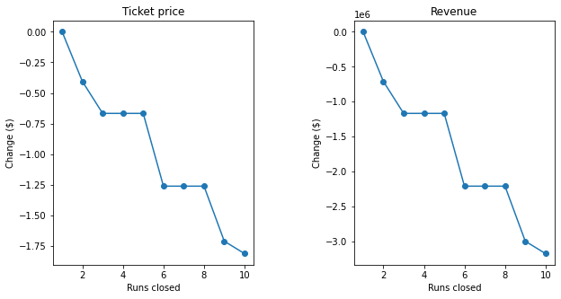

**Scenario 2:** This scenario calls for adding a run, increasing the vertical drop by 150 feet, and installing an additional chair lift. This scenario support increasing the ticket price by $1.99. Over the season, this could be expected to increase in revenue to the amount of $3,474,638

**Scenario 3:** This scenario calls for adding a run, increasing the vertical drop by 150 feet, and installing an additional chair lift, adding 2 acres of snow making. This scenario support increasing the ticket price by $9.90. Over the season, this could be expected to increase in revenue to the amount of $17,322,717

**Scenario 4:** This scenario calls for increasing the longest run by .2 miles and guaranteeing its snow coverage by adding 4 acres of snow making capability. It does not make any difference in revenue.

So among the above Senarios, we recommend Senraio 3 which results in increasing the revenue to the amount of $17322717.